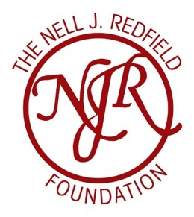

Special Request for Proposals [RFP]

Collaborating in the Homelessness and Poverty space

A limited number of one-year Innovation Grants of up to $20,000 are available in 2024

Requirement:
- A minimum of TWO non-profit agencies delivering services in this space working together on a new initiative

Submission Criteria

Overview
The purpose of this Request for Proposals (RFP) is to encourage creative collaboration by agencies who specifically specialize in providing services to those struggling with homelessness, housing insecurity, and/or poverty to work in partnership on a new innovative initiative.
- Describe your proposal
  - What gap in current services is this new initiative addressing?
  - How does addressing this gap through collaboration strengthen the overall service delivery to our community?
Background
- Briefly describe each of your agencies- e.g., mission
  - share the 2 biggest services each of your agencies provide
  - where do each of your agencies operate [mostly] along the Homelessness --Poverty continuum?
Budget and Scope of Work
The one-year grant award is for up to $20,000.
- Specify how the funds will be utilized
  - To specifically do what work? [can use some funding for professional learning, with the stipulation of presenting back to the community]
- Specify what evaluation processes you will use to address the question – ‘what was gained from our efforts?’
Selection Criteria
The grantees should:
- Be Redfield partners that address the gap in services with this grant
- Describe a clear process from ideation, implementation, quality adjustment and improvement, and sustainability
- Produce a clear report at the end of the one year grant cycle including proposed sustainability of the initiative and be willing to present your findings at a gathering (TBA)

Submission Process
Submissions may be sent electronically by the submission deadline[s] to:
- Email Address: dwesner@redfieldfoundation.org
Timeline
Proposals must be submitted by May 15 for funding consideration for a grant from June 2024 to June 2025; by August 15 for consideration for a grant from September, 2024 to September 2025; and November 15 for consideration for a grant from December 2024 to December 2025.
A submission must also include:
- Description of the agencies that includes a general overview including number of full-time employees, and names and credentials of the team members assigned to work on this initiative.

Note: Collaborative grants will be awarded in addition to current grant funding budgeted for Redfield partners. Applications (or declining to apply) to this specific collaborative grant opportunity are not intended to impact current grant-making by the Redfield Foundation.

For more information, please email kcoll@redfieldfoundation.org

Also see www.nelljredfieldfoundation.org

